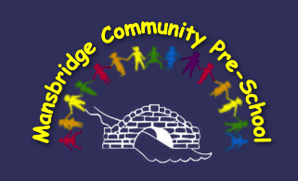

**Policies and Procedures**

**Mansbridge Community Pre-School**

* 1. **Sun Protection Policy**

**Policy statement**Too much exposure to ultraviolet (UV) radiation from the sun causes sunburn, skin damage and increases the risk of skin cancer. Sun exposure in the first 15 years of life contributes significantly to the lifetime risk of skin cancer. At Mansbridge Community Pre-School we want the staff and children to enjoy the sun safely. We will work with staff and parents to achieve this. It is the responsibility of each parent/carer to apply sunscreen to their child before bringing them to Pre-School. It is our Policy that staff will not apply sun cream to children who only stay for a morning or afternoon session as parents need to apply this prior to coming. Staff will only apply sun cream to children staying all day which is provided by the setting and parents have given permission. Staff may apply to any child with parental permission if necessary.

Mansbridge Community Pre-School’s sun protection policy has been developed to ensure that all children and staff are protected from damaging levels of ultraviolet (UV) radiation from the sun.

**Procedures**

All children and staff use a combination of sun protection measures throughout the day to ensure they are all protected.

* **Shade** – We have canopies to provide shelter and shade across the outside area. The availability of shade is considered when planning excursions and outdoor activities. Children are encouraged to use available areas of shade when outside.
* **Clothing** – When outside, parents are advised to dress their children in loose fitting clothing that covers as much skin as possible. Tops with elbow length sleeves, and knee length or longer style shorts and skirts are best.
* **Hats** – Parents are advised to send their children with named hats that protect their face, neck and ears, e.g. legionnaire style. We will actively encourage all children to wear a sun hat when playing outside.
* **Sharing information about sun protection** – We will talk about the sun and its effects on us on a regular basis. Families are provided with information on this policy and sun protection through newsletters and other information.

Reviewed 14.10.2024 by S.King