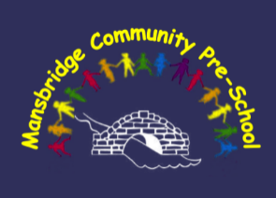

**Policies and Procedures**

9 Childcare practice procedures

**9.14 Fee payment**

Fees are invoiced at the start of each half-term for that half-term. Payment is due half-termly, monthly or weekly in advance. If payment is made weekly, then it should be made at the beginning of the child’s first session of the week. The amount to be paid each week is to be shown on the invoice. Fees are still payable if your child is off for any reason e.g. unwell, isolating, holidays etc.

Payment may be made by cash or by online banking (BACS). The details for BACS payments are to be included on the invoices, overdue fee notices and also made available upon request.

If fees are more than 2 weeks overdue, and the parent/carer has not agreed with the manager when payment will be made, then an overdue fees notice will be issued.

The overdue fees notice will state:

* The amount outstanding
* The date by which this must be paid (1 week)
* That weekly fees must be paid on time in future
* That the child may not be admitted to lunch sessions or sessions for which fees are charged until the overdue balance is paid and that there is no guarantee that the child’s space will be kept available if this happens.

Where there is difficulty in paying the fees a reasonable payment plan may be agreed with the parent/carer.

If, following the issue of the overdue fees notice, no payment is received, and no payment plan is agreed the Pre-School may refuse to admit the child to lunch sessions or any other fee paying sessions until either payment is made in full or a payment plan is agreed. There is no guarantee that the child’s space will be kept available.

Also, if a payment plan is agreed, but the parent does not keep to it, then the Pre-School may refuse to admit the child to lunch session or any other fee-paying sessions until the amount overdue is paid. Again, there is no guarantee that the child’s space will be kept available.

It is expected that in the majority of cases where payment has not been made and a payment plan has not been agreed or has not been kept to, that the child will not be admitted to lunch sessions or any other fee paying sessions in order to stop the debt accumulating but, there may be exceptions and this will be assessed on a case by case basis.

If fees are not paid and your child leaves the Pre-School, legal action will be taken.